

THE UNIVERSITY OF BRITISH COLUMBIA

COSC #360

GameX Documentation/Walkthrough

SEPT 2021 - DEC 2021

**Gerald Promchuakaew #90113853**

**Willam Chen**

**Alvin Villafranca**

Walkthrough

First, you are welcome to our home page. This is our gaming blog where you find discussion boards you are interested in. You also have the options to create and account or login on the top of the page.

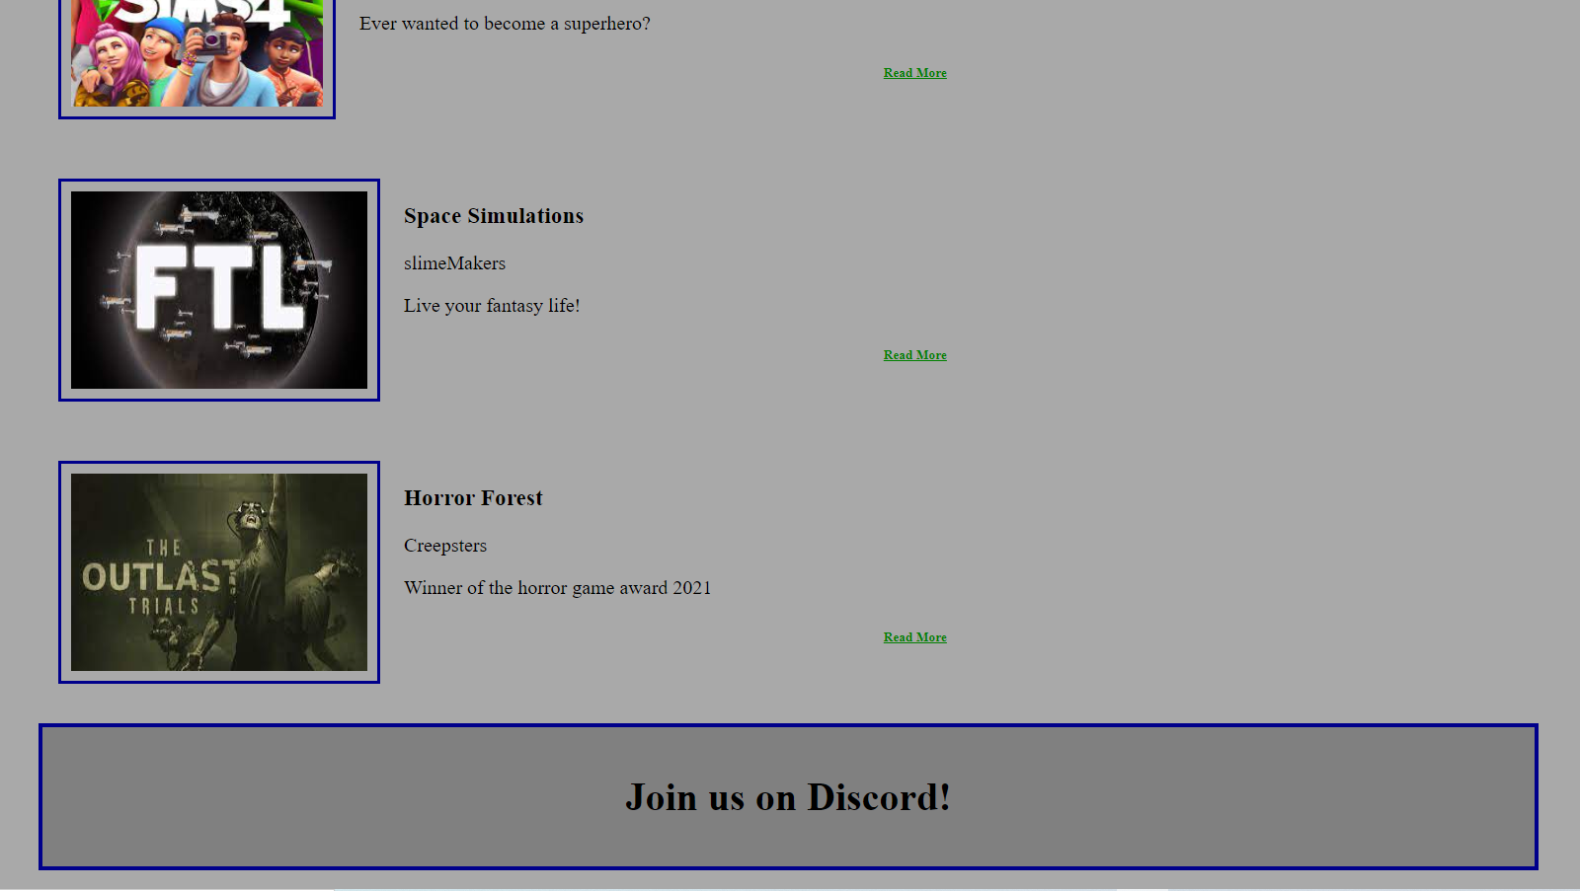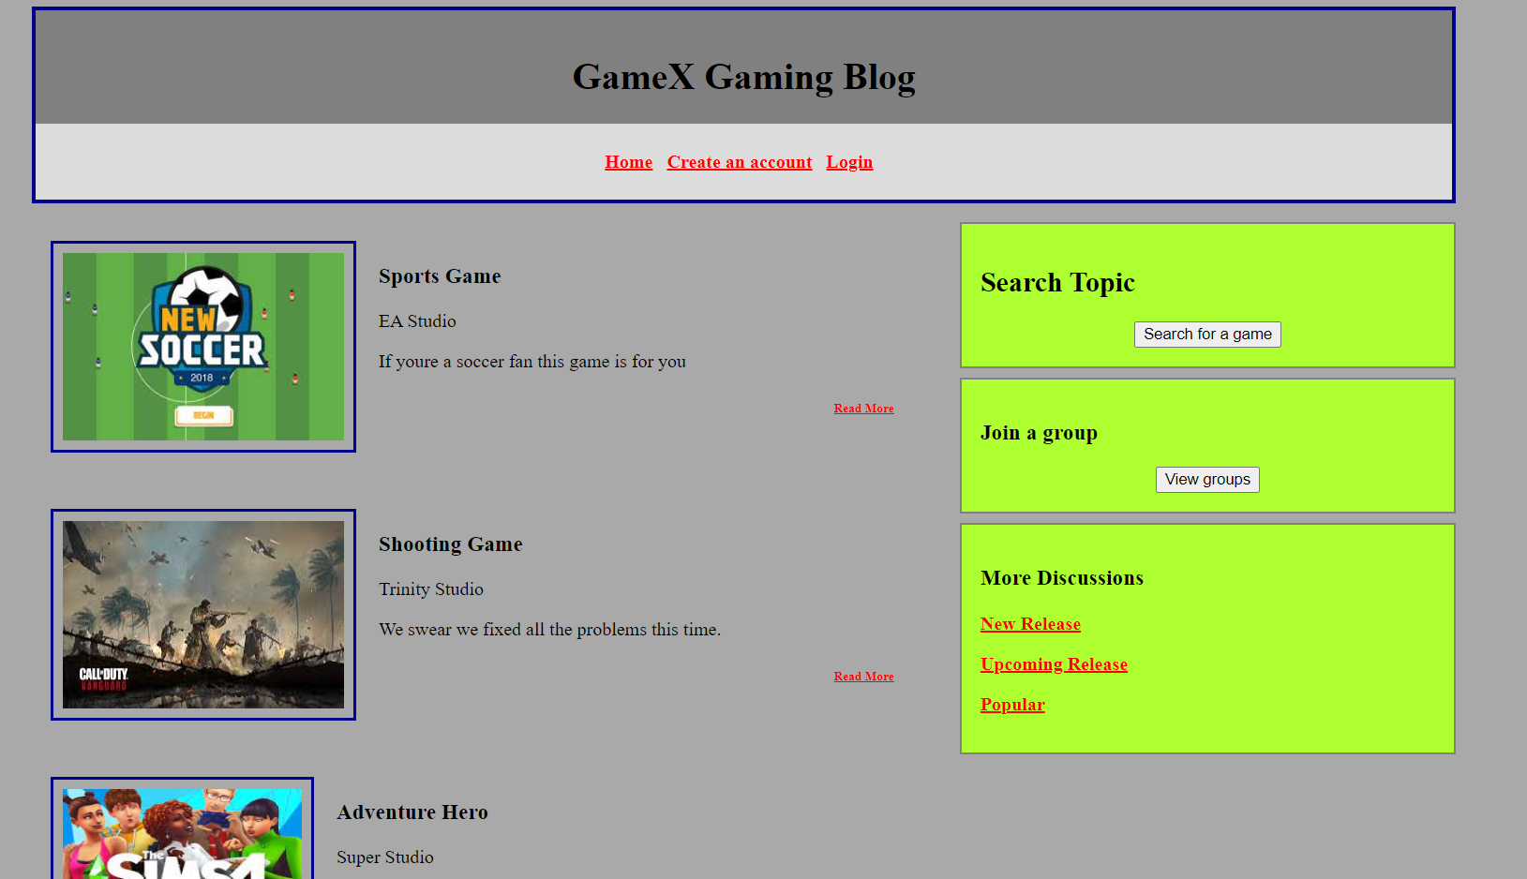

If you click on create an account hyperlink at the top, it will take you to our signup page: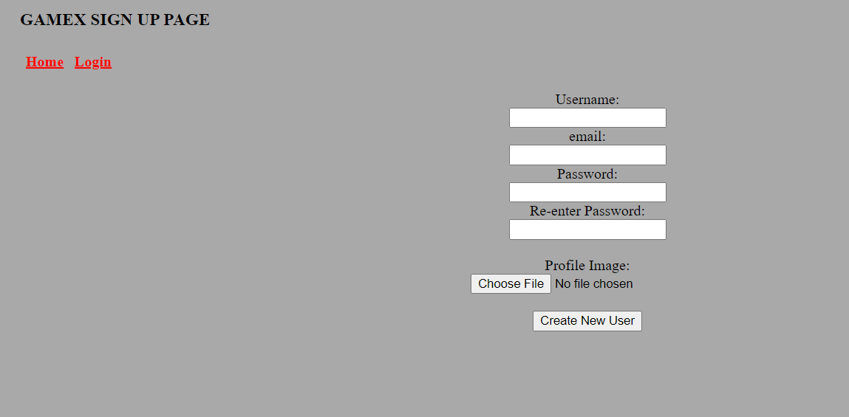

On this page you are directed to put in your desired credentials as shown in the picture above. Once you have filled in all the required spaces, you can go ahead and click create new user. This will save your information in our sql.

From here on: You can sign in with your own credentials and have your own account.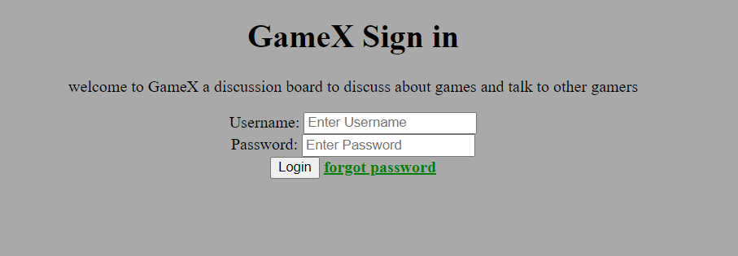

If you already have an account and you click on login the website will redirect you to to our login page:

Here, you have to enter your username and password that you used to signup, then you can click login. This will log you in to your own account and you can browse our website’s discussion boards freely as your account.

Forgot password page:



From the home page, if you click on “read more”, it will take you to this page where you can see the discussions from other members on the board: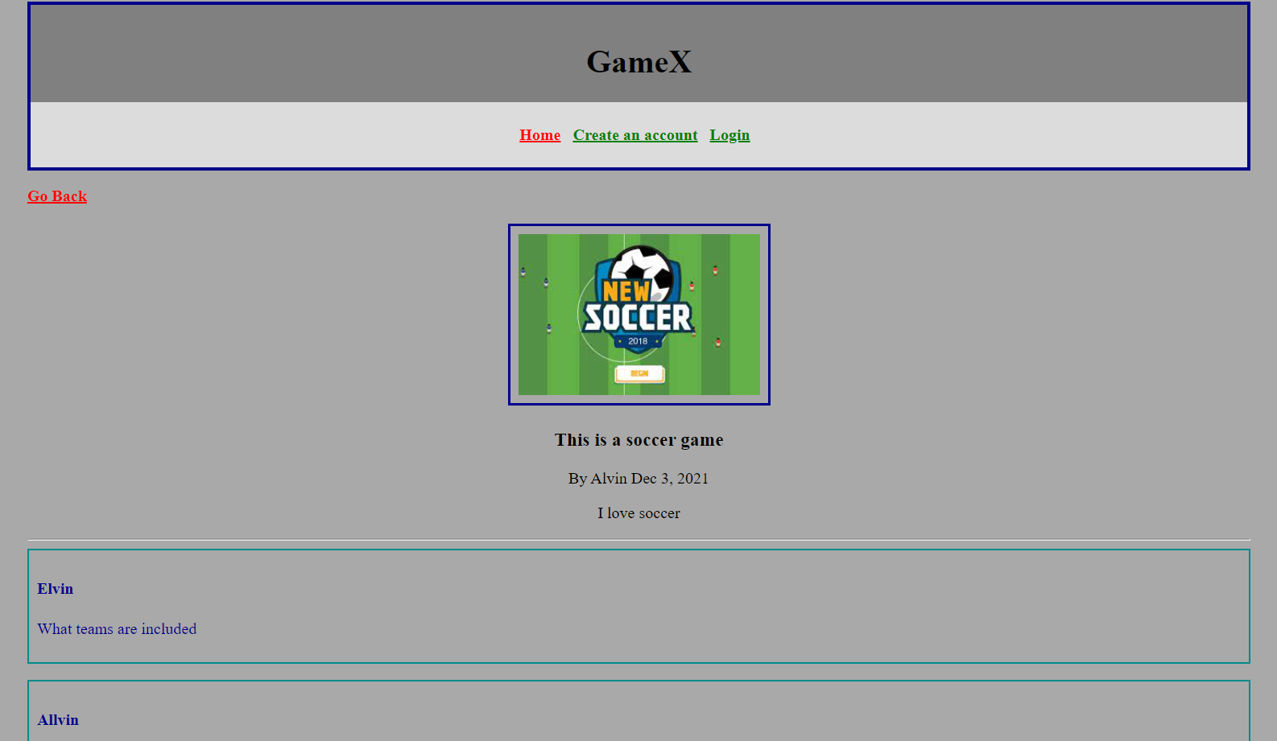

If you click on the “search for a game” button, this site will take you to this page where you can search for the specific discussion boards you desire: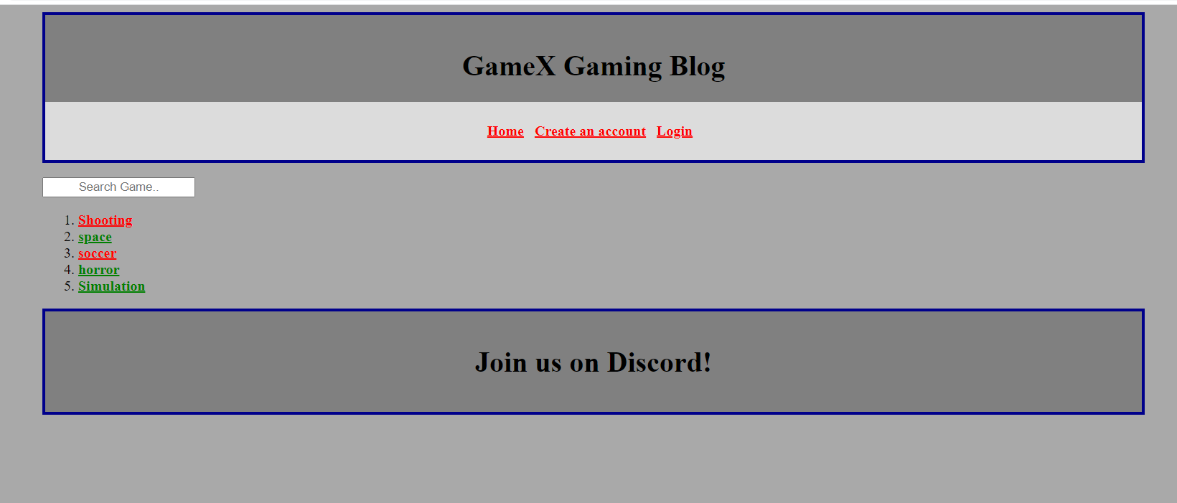

If you click on “view groups” button, the site will bring you to this page where you can look at all the groups that this website has to offer”:

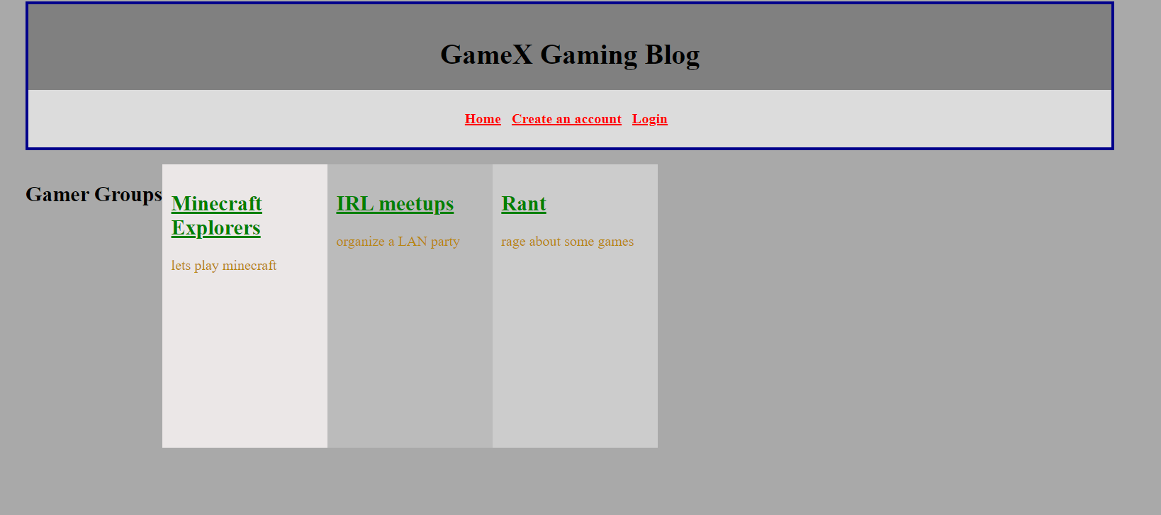

Create Post page: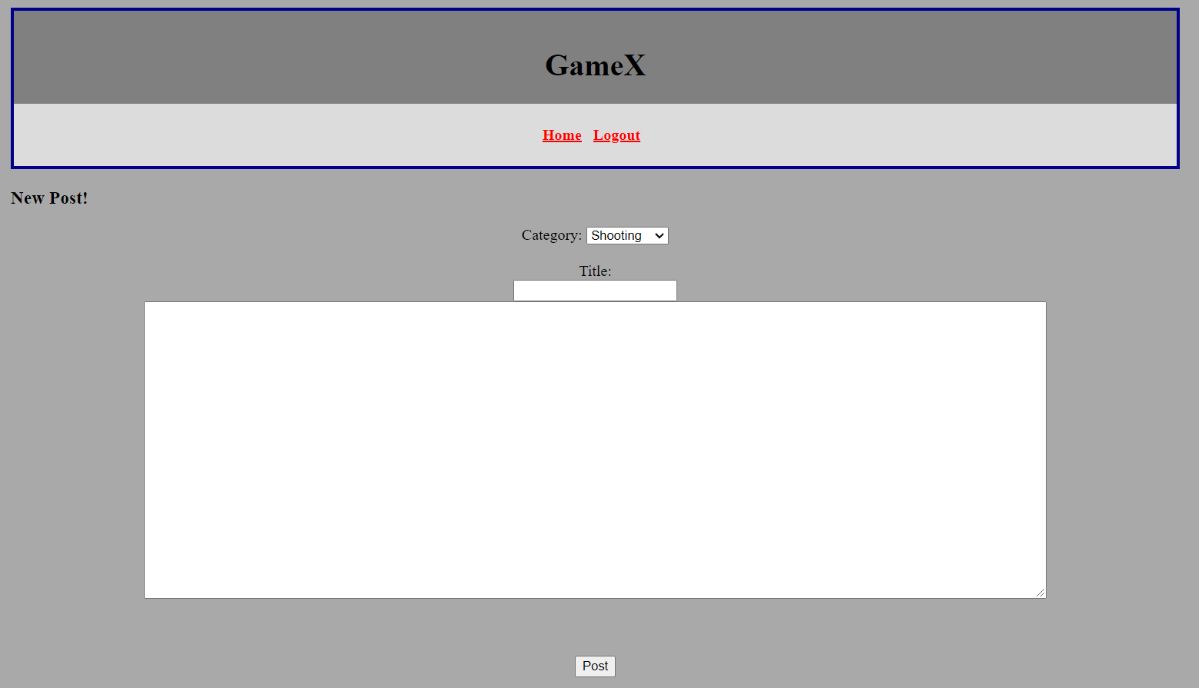

Admin page: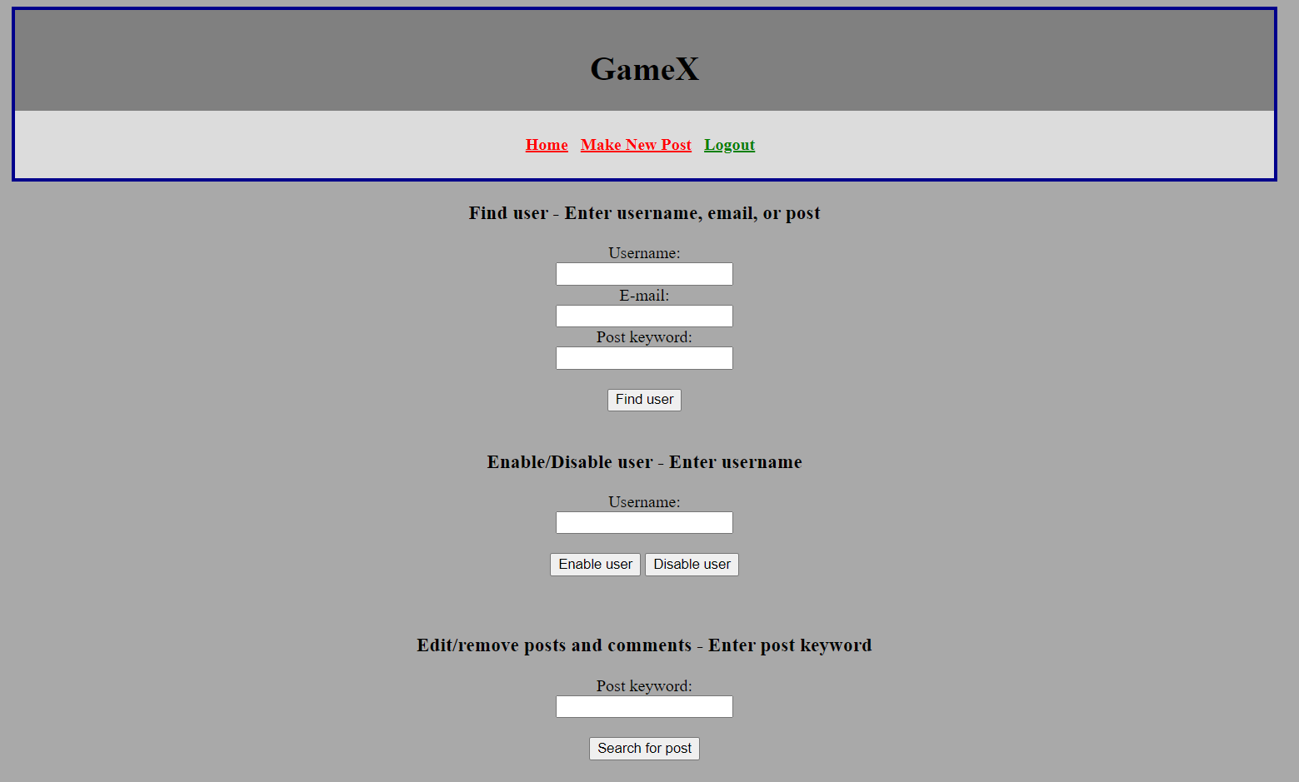

To log into the Admin Page the user must input a non hash protected password provided by The Database



Implementation

To create GameX the gamers discussion board, I used html, css and javascript for the front end/Client side scripts and PHP to handle server side inputs.

For members and visitors:

• Sign-up for with username, password, e-mail, and profile picture

-User is able to view discussion boards

-Search topic by search bar

-Click on collapsible button

-login/Sign-in/logout

• Login with username and password

• Create posts when logged in

• Select topic when creating a post

• Allow users to edit their own profile

• Password recovery by e-mail

For administrators:

• Search for

• Delete user accounts

•Able to edit posts

PHP Files

There are PHP files linked to their own respective html. They will check server request method,

and if the requested method is not POST, it will display error message accordingly. The PHP

files handle various user inputs and display appropriate message. For instance, in

createAccount.php, the file will verify server request method and will show a message to let the

user knows the account has successfully been created.

JavaScript File

Javascript was used to check if html form fields were filled in and passwords were not the same. Also some functions help implement how the user is able to interact with the page. Such as search for a topic and expand on a topic

Limitations

The project has not fully implemented way to add comments and bug testing. It has fundamental and has the php scripting but lacks any testing due to resource restraint.